Make HTML Accessible in D2L

Prepare

Save an Image
In this session, we will be adding an image to an HTML file. Save the image to your computer (preferably the desktop) so we will be able to locate it later.
- Go to the Instructional Services Website: http://ww2.nscc.edu/lyle_l and click on Accessibility. The image is under the heading, "Files and Links for March 18, 2015, Training."
- Right-click on img001.jpg and choose "Save picture as" or "Save image as" depending on your browser.
- Save the picture to your computer. Saving it to the desktop will help us locate it later in the session.

Copy Unformatted Content (to save time typing)
- Go to the Instructional Services Website: http://ww2.nscc.edu/lyle_l and click on Accessibility. The content is in a file under the heading "Files and Links for March 18, 2015, Training."
- Click on "Syllabus_No_Formatting.htm."
- Select and copy all of the text. (CTRL + A to select all) (CTRL + C to copy) This places the text in the PC Clipboard.

Create or Edit a Document in D2L
- Go to one of your D2L courses.
- Create or select a module.
- Click the New button and select "Create a File."
- Enter a title for the document.
- For this exercise:
  - Click on "Select a Document Template" then "Browse for a Template."
  - Choose "Shared Files" (at the left)
  - Click on the "Styles" folder.
  - Click on D2L Basic.
  - Click the radio button to the left of "D2LBasicTemplateEmbeddedStylesGeneral.html" then click the Add button.
- You will see a blank screen; however, styles have been added to the file. (More on that after we paste and edit a document.)
- Paste the text you copied to the clipboard. (CTRL + V to paste)
- Click on Update to Save. (so we don't lose the content)."

Insert an Image and Add Alt Text
- To add an image in D2L,
  - Ensure that you are in edit mode. Click the arrow next to the title of the document, and choose Edit HTML.
  - Click on the Insert Image icon (second from the left.)
  - Choose My Computer, then click on Upload. Locate the image you saved to your computer: (img001.jpg). Click on Open. Click on Add.
  - A dialog box displays. Enter the alt text or select “Decorative.”
NOTE: If you are working with an image that is already displayed in the web page, I have not found a way to add alt text using the dialog box without clicking on the image and re-inserting it.
ALTERNATIVE METHOD: For images without alt text, go to the HTML code and add the following to the img tag: alt=”words that describe your image.”

Assign Headings and Lists
- To assign headings and lists to a document,
  - Headings
    - Click anywhere within the text to be tagged as a heading.
    - Select the heading level from the format menu. (4th item from the left)
  - Lists
    - Select the items that should be identified as a list.
    - Click the icon (10th from the left) for an unordered list or click the dropdown arrow for an ordered (numbered) list.

Add a Table Header and Caption
- To add a caption to tables,
  - Click inside the table and click on the table icon . Check the table caption checkbox. Save the changes. A blank line is created immediately above the table and is a placeholder for the caption text.
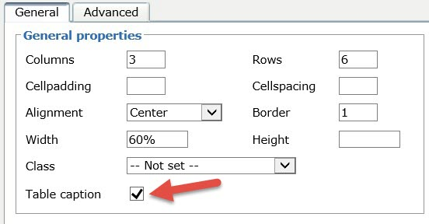
  - To type the caption, click on the blank line immediately above the table, for example, "Schedule of Dates, Assignments, Quizzes and Tests."
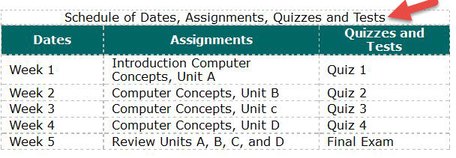
- To assign column headers,
  - Select the cells in the top row.” Click the arrow next to the insert table icon and select Table cell properties.
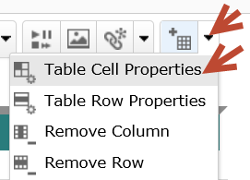
  - On the table cell properties dialog, choose “Header” for Cell type.
NOTE: The World Wide Web (W3C) guidance on using table heacers states:"For simple tables that have the headers in the first row or column, it is sufficient to simply use the Table Head <th> elements without scope." We recommend that you use simple tables. When you click on Update, without choosing a Scope, D2L will prompt you to consider adding scope. You may choose to add scope. In listening to the JAWS screen reader, the results appear to be identical. Click on Update.
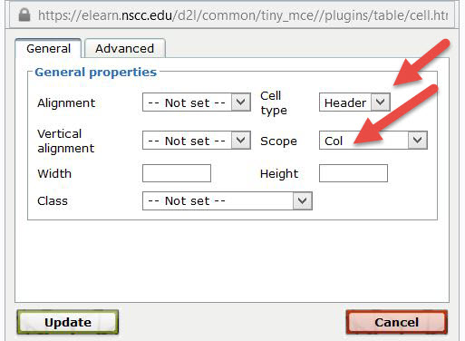
  - The cell headers will be bold and centered.
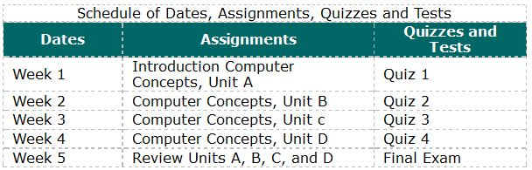
  - NOTE: Some tables may be organized so that the headers are down the left side of the table in the first column. In that case, you would select the cells in the first column and follow the same procedure as described above except the scope would be row (if you choose to select scope.)

Edit a Link
- To edit a link,
  - Select the link.
  - Click on Quicklink. (3rd from the left)
  - Click on URL (you may have to scroll down)
  - In the "Title" box include meaningful words. If it opens in a new window, add (new window) to the link text.
  - The "URL" box should include the http address.
  - Select New Window.
  - Click on Insert.

Edit Text Color
If you choose to select a text color, check the contrast. Observe the rule that any color assigned to text must also be identified in another way--such as bold or italics. Underlined text is not recommended. Screen readers do not announce a change in color of text.
- To edit text color,
  - Select the text.
  - Click on the icon (13th from left) to apply/select color.
  - Select a text color. Note whether it passes the WCAG AA Contrast Ratio.
  - Click on Save.

Avoid These D2L Features
If at all possible, avoid using the font family and size selections in D2L. A best practice is to control fonts and size with a style sheet.

